Which one of the following is molozonide?
A. 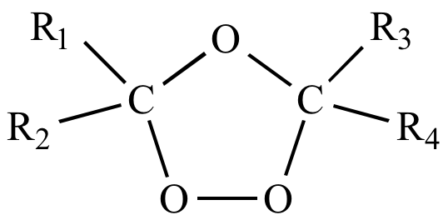
B. 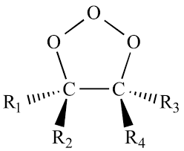
C. 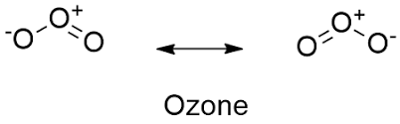
D. All of these
ANSWER: B
Ethene give _____ on ozonolysis.
A. Polymer
B. Molozonide
C. Ozonide
D. Carbonyl compounds
ANSWER: C
It is the intermediate product formed during ozonolysis.
A. Molozonide
B. Ozonide
C. Carbonyl compounds
D. Carbon dioxide
ANSWER: A
What will be formed when ozonide undergo reduction?
A. Molozonide
B. Ozonide
C. Carbonyl compounds
D. Carbon dioxide
ANSWER: C
Complete the following reaction.
$$H_{2}C=CH-CH_{3}+HCl \underset{→}{ }$$
A. $(Cl)CH_{2}-CH_{2}-CH_{3}$
B. $H_{3}C-CH\left(Cl\right)-CH_{3}$
C. $H_{3}C-CH\left(Cl\right)-CH_{3}$ and $(Cl)CH_{2}-CH_{2}-CH_{3}$
D. None of these
ANSWER: B
Halogenation of chloroethane will produce
A. Vicinal dichloride
B. Geminal dichloride
C. Vicinal dichloride and geminal dichloride
D. 1,2-dichloro ethane
ANSWER: B
According to Markonikov’s rule,
A. Halogen is added to that carbon which contain least number of hydrogen atoms while Hydrogen is added to that carbon which contain greater number of hydrogen atoms
B. Halogen is added to that carbon which contain greater number of hydrogen atoms while Hydrogen is added to that carbon which contain least number of hydrogen atoms
C. Halogen is added to that carbon which contain least number of hydrogen atoms while Hydrogen is added to that carbon which contain least number of hydrogen atoms
D. Halogen is added to that carbon which contain greater number of hydrogen atoms while Hydrogen is added to that carbon which contain greater number of hydrogen atoms
ANSWER: A

Catalyst used for better production of polyethylene are _____.
A. $Al{\left(C_{2}H_{5}\right)}_{3}$
B. $TiCl_{4}$
C. Traces of oxygen
D. $Al{\left(C_{2}H_{5}\right)}_{3}$ and $TiCl_{4}$
ANSWER: D
The characteristic behavior of alkenes are ______.
A. Electrophilic addition reaction
B. Oxidation reaction
C. Polymerization reaction
D. All of these
ANSWER: D
Which of the following can undergo Nucleophilic addition reaction?
A. $C=C$
B. $C≡C$
C. $C=O$
D. $C=C and C≡C$
ANSWER: C
This process is used to prepare ghee from vegetable oil.
A. Hydrogenation
B. Halogenation
C. Hydro halogenation
D. Complete hydrogenation
ANSWER: A
Which product will be formed when alkene undergo halogenation reaction?
A. Cis
B. Trans
C. Cis and Trans
D. None of these
ANSWER: B
It is formed on reaction of alkene with halogen in the presence of $CCl_{4}$.
A. 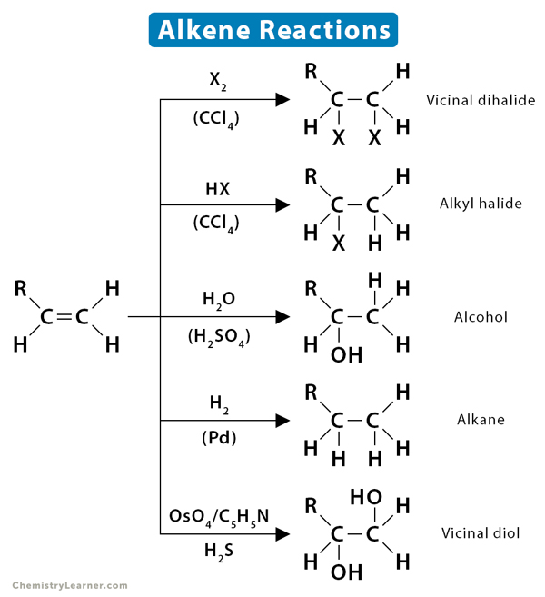
B. 
C. 
D. 
ANSWER: A
It is formed on reaction of alkene with hydrogen halide in the presence of $CCl_{4}$.
A. 
B. 
C. 
D. 
ANSWER: B
It is formed on reaction of alkene with water in the presence of $H_{2}SO_{4}$.
A. 
B. 
C. 
D. 
ANSWER: C

